**Converting Date to correct format**

The problem was that in row 26, under the date column, the format of information was wrong.

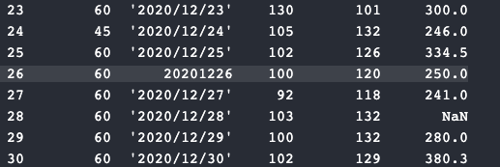

Code to fix the problem:

Df[‘Date’] = pd.to_datetime(df[‘Date’])

Print(df)

**After changing the date format:**

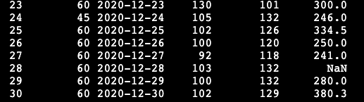

**Removing empty cells:**

Import pandas as pd

df = pd.read_csv(file name)

new_df = Df.dropna()

Print(new_df.to_string)

After removing the empty cells (28th row):

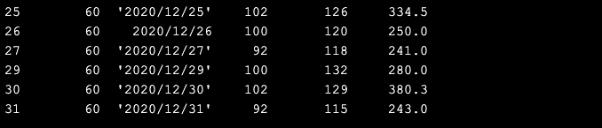

**Replacing empty cells with a value:**

Import pandas as pd

df = pd.read_csv(file name)

new_df = Df.fillna(130, inplace = True)

Print(new_df.to_string)

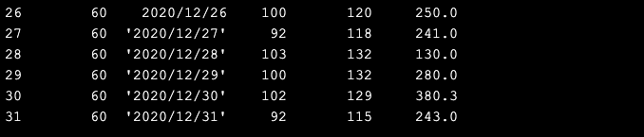

**Replacing values in a specific column:**

Import pandas as pd

df = pd.read_csv(file name)

Df[‘Calories’].fillna(130, inplace = True)

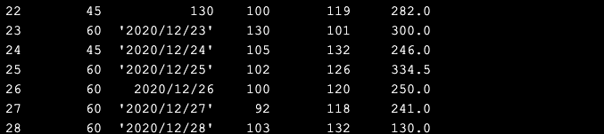

**Converting incorrect format to correct format:**



Import pandas as pd

df = pd.read_csv(file name)

Df[‘Date’] = pd.to_datetime(df[‘Date’])

Print(df.to_string())

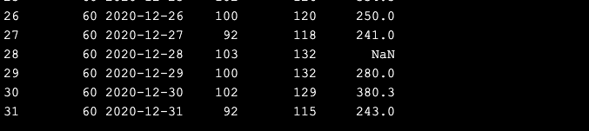

**fix wrong values is to replace them with something else.**

Df.loc[7,’Duration’] = 45

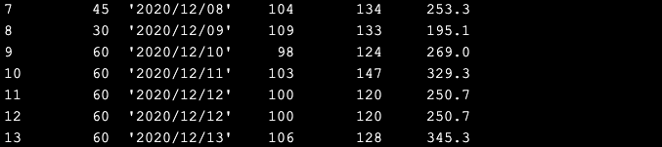

**To replace wrong data in multiple rows:**

For x in df:

If df.loc[x,’Duration’] > 100:

df.loc[x,’Duration’] = 100

**Deleting rows where the value is greater than 100:**

For x in df:

If df.loc[x,’Duration’] > 100:

Df.drop(x,inplace = True)

To remove duplicates:

Df.drop_duplicates(inplace = True)